Name:_______________________________________

Assignment 5: Graphing Puzzle Solution

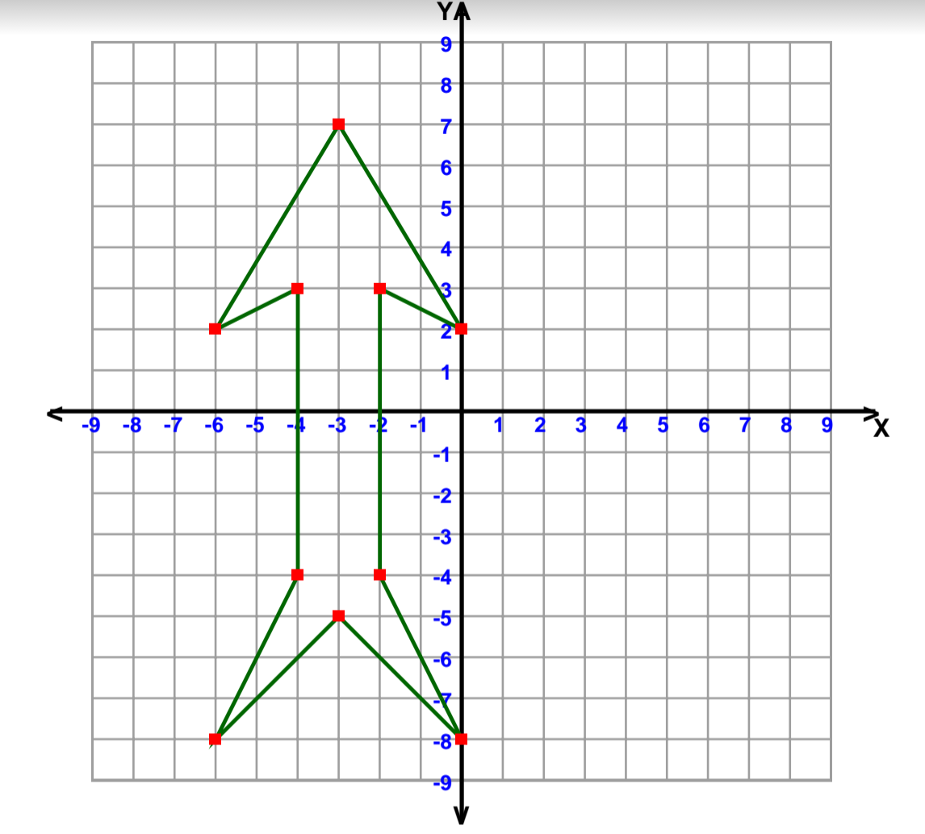

What is the shape? Arrow